1) Concat:

//load sample into sam

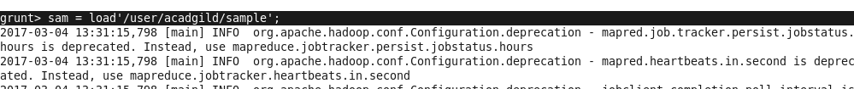

//dump the contents of sam

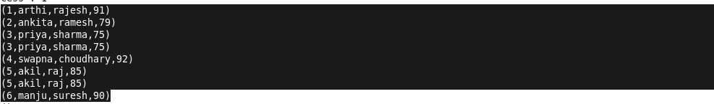

//concat operation



//result

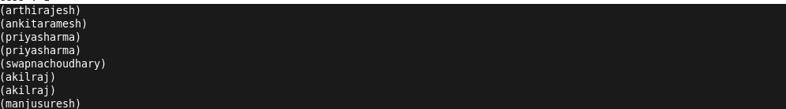

2) Tokenize:

//load sample1 into sam1



//dump the contents of sam1

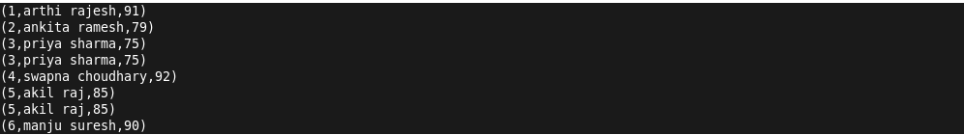

//tokenize operation



//result

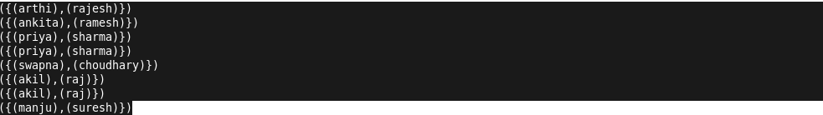

3) Sum:

//load sample1 into sam1



//dump the contents of sam1



//group operation

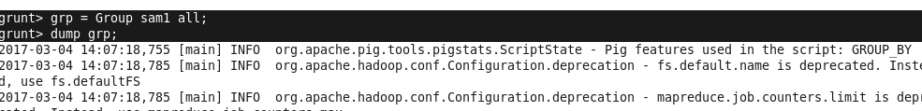

//result of group



//sum operation

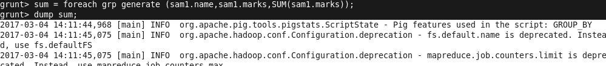

//result



4) Min:

//load sample1 into sam1



//dump the contents of sam1



//group operation



//result of group



//min operation

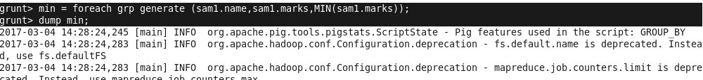

//result



5) Max:

//load sample1 into sam1



//dump the contents of sam1



//group operation



//result of group



//max operation



//result



6) Limit:

//load sample1 into sam1



//dump the contents of sam1



//limit operation



//result



7) Store:

//load pig1





//content of pig1



//store operation



// resultant dump

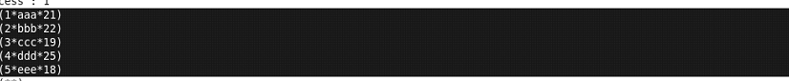

// file stored in user/acadgild/output

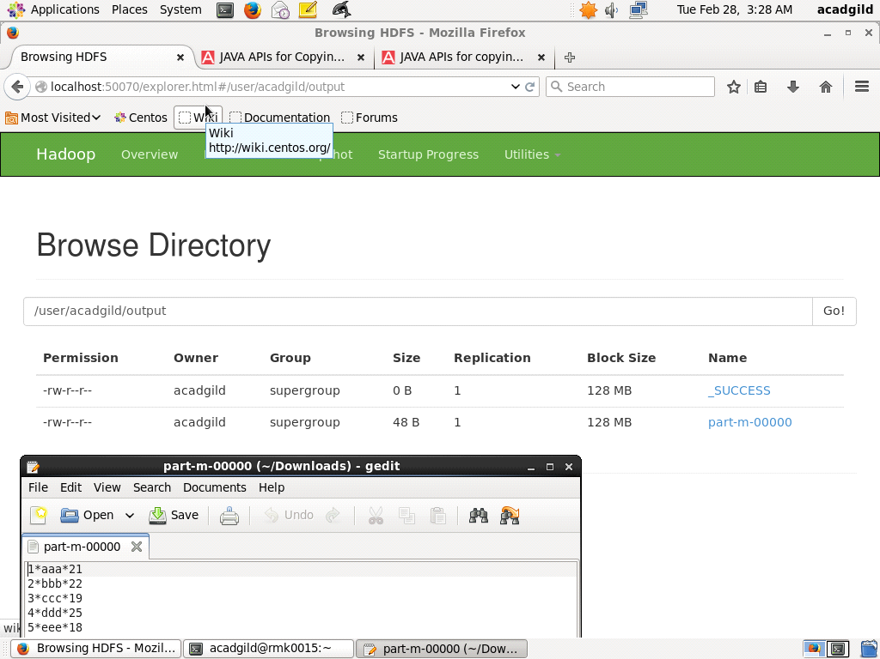

8) Distinct:

//load sample1 into sam1



//dump the contents of sam1



//distinct operation

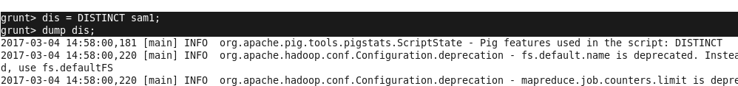

//result

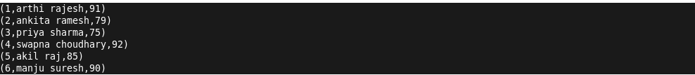

9) Flatten:

//load sample1 into sam1



//dump the contents of sam1



//group operation



//result of group



//flatten operation



//result

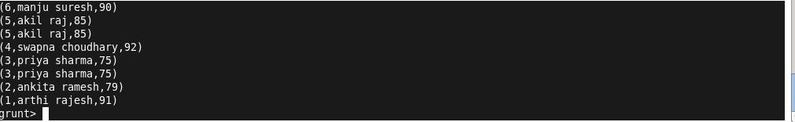

10) IsEmpty :

//contents of sam1



//contents of sam2

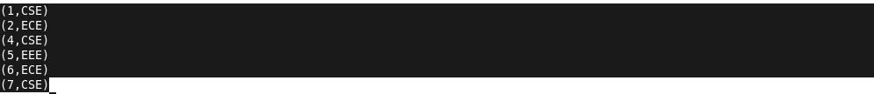

//cogroup operation

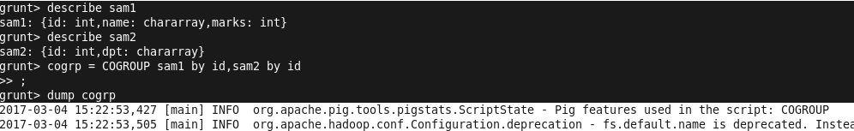

//result of cogroup

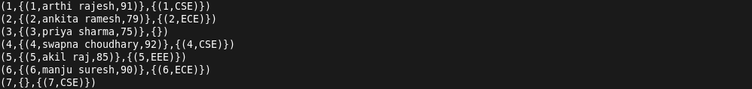

//isEmpty operation



//result

